# **Acknowledgement**

I would like to thank my parents for their ongoing support and my supervisor Mr Gilbert Mwale for the mentorship and guidance he has provided to me not only for this project, but throughout my academic journey.

# **List of Figures**

Figure 1 Respondents age representation 16

Figure 2 Respondents gender representation 16

Figure 3 Type of farmer representation 17

Figure 4 Respondents experience representation 17

Figure 5 Respondents farming methodology representation 18

Figure 6 Respondents method satisfaction representation 19

Figure 7 respondents methodology preference representation 19

Figure 8 Respondents attitude to new system representation 20

Figure 9 20

Figure 10 xampp screenshot 22

Figure 11 Agile methodology 24

Figure 12 iterative and incremental methodology 25

Figure 13 farmer side flow chart 27

Figure 14 Admin side flow chart 28

Figure 15 Entity relationship schema 29

Figure 16 Use case diagram 30

# **Table of contents**

Contents

**Acknowledgement** iii

**List of Figures** iv

**Table of contents** v

**PART ONE – INTRODUCTION** 1

**ABSTRACT** 1

**CHAPTER ONE - INTRODUCTION** 2

**1.1****Purpose of the Situation**. 2

**1.2****Background of the study**. 2

**1.3****Problem context and rationale.** 3

**1.4 General Objectives** 4

**1.4.1 Specific Objectives** 4

**1.5 System Functionality** 4

**CHAPTER TWO - PROBLEM DESCRIPTION** 6

**2.0 Introduction** 6

**2.1 Statement of the Problem** 6

**2.2 Significance of the problem.** 7

**CHAPTER THREE - LITERATURE REVIEW** 7

**3.1 Empirical Review.** 7

**3.3 Reviewed Systems.** 10

**CHAPTER FOUR - METHODOLOGY** 11

**4.0 Introduction** 11

**4.1 Research design and approach** 11

**4.2 Sample size** 11

**4.3 Sources of data** 11

**Mixed Questionnaire participated by farmers on social media (Facebook and WhatsApp).** 11

**Objectives of the questions asked in the questionnaire.** 13

**4.4 Methods of data collection** 14

**4.5 Ethical consideration** 15

**CHAPTER FIVE - ANALYSIS AND DESIGN** 16

**5.0 Introduction** 16

**5.1 Data Analysis** 16

**5.2 System Platform and Requirements** 21

22

**5.2.1 Functional Requirements** 22

At this stage, user requirements and system specifications were gathered. Which led to functional and non-functional requirements, programming language to use, database model and hardware specifications 22

**5.2.2 Non-functional Requirements** 23

**5.2.3 Hardware Requirements** 23

**5.2.4 Software Requirements** 23

**5.2.5 System Development methodology** 24

**5.2.6 System design** 26

**5.2.6.1 Flow Chart Diagram** 26

**5.2.6.2 Relationship Schema** 29

**5.2.6.2****Use Case Diagram** 30

A use case diagram summarizes the details of your system's users (also known as actors) and their interactions with the system. It uses a set of specialized symbols and connectors. An effective use case diagram can help your team discuss and represent scenarios in which your system or application interacts with people, organizations, or external systems and Goals that your system or application helps those entities (known as actors) achieve 30

**CHAPTER SIX - IMPLEMENTATION** 31

**6.0 Introduction** 31

**6.1 System Coding** 31

**CHAPTER SEVEN - TESTING** 39

**7.0 Introduction** 39

**CHAPTER EIGHT - CRITICAL EVALUATION** 41

**8.0 Introduction** 41

**8.1 Limitations** 41

**8.2 Benefits** 43

**CHAPTER NINE - CONCLUSIION** 43

**References.** 44

**APPENDICES** 50

**Installation Manual** 50

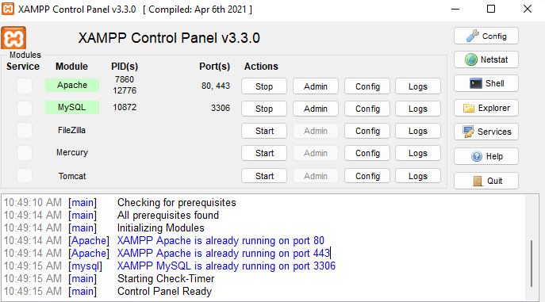

# **PART ONE – INTRODUCTION**

# **ABSTRACT**

Agriculture as an old profession dates back to the early Stone Age and considering the consistent paradigm shifts and evolution of humanity, there is an urgent need to embrace and appreciate the power of technology. The Agro sector remains vigilant to face the challenges of change by employing new strategic advancements that facilitate the efficiency and effectiveness of agricultural production such as the diesel engine tractors and other equipment with hydrodynamic capabilities which help to overcome food challenges and meet the increasing demand for food, increase food productivity and industrialization.

The researcher participated in an internship program where the organization trains new and old farmers on a variety of topics in agriculture, the researcher observed that farmers are still using orthodox methods of farming and cultivation in Zambia is mostly non-mechanized, and the sector is overwhelmingly rain-fed because large capital investments are needed to acquire farming equipment. Despite how expensive it might seem to gain entry into the industry, given the necessary equipment agriculture is very profitable for the individual and the nation at large.

Considering those facts, the researcher decided to develop farm equipment hiring system that enables farmers who cannot afford to purchase expensive farm equipment, to purchase them for hire at an affordable rate. The system will be a web-based website that will be accessible to farmers that have access to an internet connection.

The equipment owners will upload photos, description of the product and prices per hour on the website. Farmers will then select their desired equipment from the available dates and the system will calculate the total amount. With this solution the farmer may start their farming activities without high capital costs.

# **CHAPTER ONE - INTRODUCTION**

# **Purpose of the Situation**.

People find agriculture unattractive because their perspective on farming is a dirty job that requires hard labour and according to article written on the Lusaka time’s website “Agricultural development can lead to higher job and growth creation and stimulate economic development outside the agricultural sector. Zambia’s agricultural contribution to GDP in 2020 was disappointing 2.73% per cent, while neighbouring countries were Zimbabwe 5.07%, Angola 7.3%, Namibia 9.03%, Malawi 21.09%, Mozambique 26.03%, and Tanzania 26.74%.” (Lusaka Times, 2021)

The world is already currently a facing food crisis in regard to the Ukraine and Russia war, together they export about 30% of the world’s wheat, 60% of the world’s sunflower oil which is the third most traded seed oil after palm oil and soy oil, and about 20% of the world’s corn (GLG, 2022).

Concerns about these countries’ ability to fulfil demand come at a time when inflation, poor weather forecasts, and soaring energy prices have already raised the stakes for agriculture markets. The worst of the trouble is still a few months away, and the wheat market might face significant price hikes because of the effects the war would start to impact 2022 crop planning.

To Increase agricultural production will be one of the greatest problems to face humanity in the near future. Research has shown that small, medium and large scale farmers have issues regarding accessibility to modern farm machinery. Small scale farmers face difficulties in having access to those tools expected to boost their farm activities and eventually affect productivity. However, according to a research conducted by  International Trade Administration (Anon., 2021) revealed that the major factor limiting the farmers residing in this part of the country (Zambia) is the lack of access to a major farm machinery, tractor in this case, to work on their farms.

So many farmers have gone out of business and the remaining few are suffering from increasingly reduced farm productivity due to lack of access to farm machines that could make farm operations less tedious with improved productivity. The proposed idea is to provide a farm machinery hiring system for these farmers at a subsidized rate. The contributions of this study include: Guaranteeing reliable up to date information on machines acquisition and hire; offering real time information on hiring system with respect to availability based on database record.

# **Background of the study**.

Agriculture, the science or practise of farming, including cultivation of the soil for the growing of crops and the rearing of animals to provide food will and other products.

In the beginning, or at least the beginning of the human race, it is believed that we were a species of hunter gatherers, mostly nomadic, moving from place to place in search of food. Some societies travelled vast distances in synchronicity with the change of seasons. Then around 7000 BC, or about 9000 years ago, give or take a couple of 1000 years, a number of tribes began collecting seeds from grass and vegetation that were a food source on their nomadic roots and replanted them in regions preferred for year round dwelling. The idea was that if one could grow, harvest and store enough food during the local growing season to last throughout the non-growing season, a tribe could build a permanent community and put down roots, so to speak. So that worked for seeds, grains and grass is as they could be dried and stored, then ground and cooked to make bread or any number of savoury dishes.

The plough, from the moment humans conceived of growing food from seed, it became apparent that it would be necessary to cultivate or prepare the soil for planting. Initially, a hand held hoe was used to break up the soil, but this was extremely labour intensive, especially when trying to cultivate an area large enough to feed an entire city. The plough invented in what is now India about 5000 BC, was a device designed to be pulled initially by oxen that turned the soil, and Doug furrows in straight lines or rose, allowing for efficient planting. Over a few thousand years, the plough underwent many design changes and, not to mention a spelling change. However, in the early 1700s, the swing plough was invented and emerged as a perfected standard. It is to this very day the instrument used at all historical ploughing events and competitions.

# **Problem context and rationale.**

In today's fast paced, technologically advanced global economy, we can get just about whatever we want whenever we want. And with the large number of product from Africa and developing countries and their low wages, well, it's hard to resist the temptation to buy imported produce. But there’s a problem in our quest for finding the lowest price on items, we end up importing what we want or need from thousands of kilometres away and that includes food that we already grow in our own backyard. If food has to travel thousands of miles, and according to studies, the average is 1400 miles, it needs to either be picked before it is ripe, refrigerated and artificially ripened, chemically treated, or genetically altered to maintain its visual appeal when it arrives at the local supermarket. Consider the fuel costs. Or the environmental impacts of trucking and transporting so called fresh produce, canned or frozen goods from thousands of miles away.

Our local farmers struggle to compete and survive in this global market. If we lose these farmers, the negative effects will be substantial unemployment, and our limited prime farmland will be allocated to housing and industry, and independence on the stability of World Trade and fossil fuels, to name a few.

With the farm equipment hiring system, local farmers should be motivated and encouraged to grow fresh and healthy food, and deliver it to the market in season, and dive in farming mechanized to boost the overall produce and production with the lowest cost of production

# **1.4 General Objectives**

To create an online system that links farm equipment lessors and lessees together anywhere, anytime in order to Increase agricultural production and satisfy increasing demand.

# **1.4.1 Specific Objectives**

* To offer a platform for equipment lessors to list their equipment for hire to a wide reaching audience to make a profit
* To create an online system that enables farmers who cannot afford to purchase expensive farm equipment, to purchase them for hire at a cheaper rate
* To assist suppliers with schedule management on the availability of equipment

# **1.5 System Functionality**

The system is a web app project developed in PHP and mainly focuses on dealing with customers and their cart items. It displays all the available products on the right side where as categories are shown on the left side. The project is divided into two sections: the farmer section and the Admin section, the admin has full control of the website. A farmer is then required to log in or register their account and a display of the available products are automatically rendered, the farmer can add products to their cart with a certain quantity. After the farmer is satisfied with the equipment and the total price, the farmer can proceed with the payment process.

Similarly, the admin plays the main role in implementing the system. Admin is responsible for viewing all orders, managing the product lists and their categories, viewing total customers and their respective details. In order to add a product, an admin must provide a suitable product name and selecting a category and should enter a description, quantity, the rate a farmer is supposed to pay for renting the equipment and the product image. Last but not the least, the admin can check the order status of the customer with their respective product names and the **Transaction Reference** id. For the User Interface elements, a free open-source CSS framework Bootstrap is being used.

**Available Modules:**

* Customer Login/Register
* Admin Panel
* Add-To-Cart module
* Product categories
* Payment module
* Manage admin
* View customer’s order details
* Product management module

**Platform**

The platform that was used for development is **Visual Studio Code**

**Development Languages**

Front end

**BOOTSTRAP**

**HTML**

**CSS**

**JAVA SCRIPT**

Back end

**PHP, SQL**

**DATABASE: XAMPP**,

**Hardware requirements**

**CPU : 1.7 Ghz+** CPU

**RAM: 4GB**

**Minimum Hard drive space: 20GB**

# **CHAPTER TWO - PROBLEM DESCRIPTION**

# **2.0 Introduction**

Traditional farming adheres to traditional methods of agriculture and makes use of old age equipment and methods in order to farm such as the hoe, plough and oxen. Because orthodox methods of farming were developed before technology and more modern machinery and equipment, it uses mainly hand held equipment and a lot smaller equipment to get the job done. Some methods used in old farming are ploughing where the soil is dug to make it loose. This is to bring all the nutrients to the top and put seeds on the bottom to make the crops grow easier and better. Old ploughing methods were usually a cart and a horse pulling it across the land in order to dig up the soil and let the nutrients get to the top. Another method of old farming irrigation. Where water is transported to the soil and put on it to let the crop Grow. In older days this was usually done by buckets or a series of dishes dug around the land, so that when the rain fell, it would fill up the ditch and be able to get to the soil. This relied a lot on the weather, and meant that certain crops could only be grown in certain places or they would not get the correct amount of water or vitamins to thrive much of old farming was done by manual labour meaning that farmers needed a lot of employees to sow seeds, water them and to harvest them. This meant that people were out on farms for hours a day sometimes seven days a week making it hard work

# **2.1 Statement of the Problem**

Poverty situations in developing nations have reduced their capacity to produce food, as most farmers cannot afford seed and fertilizers. They use poor farming methods that cannot yield enough, even substantial use. The rising costs of cooking oil and other basic commodities have made it impossible for the majority poor to afford food even where it is available (Kamdor, 2007). Investments in agricultural research and development are very low in developing nations. Farmers in developing nations have continued to use outdated farming practices, low yielding seeds and poor agricultural infrastructure which limit their production capacity (ACC, 2008). Recent global financial crises have led to increase in food prices and reduced investments in agriculture by individuals and governments in developed nations resulting in reduced food production.

Food shortage is a serious problem facing the world and is prevalent in sub-Saharan Africa. The scarcity of food is caused by economic, environmental and social factors such as crop failure, overpopulation and poor government policies are the main cause of food scarcity in most countries. Environmental factors determine the kind of crops to be produced in a given place, economic factors determine the buying and production capacity and socio-political factors determine distribution of food to the masses. Food shortage has far-reaching long and short-term negative impacts which include starvation, malnutrition, increased mortality and political unrest. There is a need to collectively address the issue of food insecurity using both emergency and long-term measures. This article discusses the concept of food shortage in the world, highlighting the causes, effects and possible solutions (UNU, 1998).

The rate of population increase is higher than increase in food production. The world is consuming more than it is producing, leading to decline in food stock and storage level and increased food prices due to soaring demand amidst low supply (ACC, 2008). Increased population has led to clearing of agricultural land for human settlement reducing agricultural production (Kamdor, 2007). Overcrowding of population in a given place results in urbanization of previously rich agricultural fields. Destruction of forests for human settlement, particularly tropical rain forest has led to climatic changes, such as prolonged droughts and desertification. Population increase means more pollution as people use more fuel in cars, industry, and domestic cooking. The resultant effect is increased air and water pollution which affect the climate and food production.

Farming without equipment takes a lot longer because it's all manual labour. This means that the work goes a lot slower and needs more employees on the farm to get the jobs done. It also yields a lot less crops because it takes so much longer to do each job. And the equipment is not made for large areas of land because it yields a lot less crops farming old farming is not a suitable method for big farms or farms that supply big commercial supermarkets because it simply isn't efficient enough.

# **2.2 Significance of the problem.**

Three decades from now around 2050, the world will be in dire need to increase agricultural production by 60–110% in order to overcome food challenges and meet the increasing demand for food (Ray, 2013). As expected, this will pile pressure on resources such as water, land and energy. To Increase agricultural production will be one of the greatest problems to face humanity in the near future and hence it is very important for this problem to be addressed, not only to sustain our nation but the world at large depends on it.

If the situation is not attended to, long term effects of food shortage. These include increases in the price of food as a result of demand and supply forces. Increasing cost of food production due to the increase in fuel prices coupled with persistent drought in grain producing regions has contributed to the increase in the price of food in the world. Increase in oil price led to increase in the price of fertilizers, transportation of food and also industrial agriculture. These factors were supplemented with increased demand for varied diets among the growing middle class Asian population and falling food stockpiles contributed to global food prices (Watson, nd). Increasing food prices culminated in political instability and social unrest in several nations across the globe in 2007, in countries of Mexico, Cameroon, Brazil, Burkina Faso, Pakistan, Egypt and Bangladesh among other nations (Kamdor, 2007).

# **CHAPTER THREE - LITERATURE REVIEW**

# **3.1 Empirical Review.**

According to (WEF-World Bank-OECD, 2015) “The share of agriculture in Africa is declining, partly due to low productivity and limited value addition”. Agriculture persists as an important sector of the African economy. Although its significance in the economy varies widely across African countries, agriculture remains a vital sector for most countries. It contributes from 2.4 percent of GDP in Equatorial Guinea to 70 percent of GDP in Liberia, providing an average of around 15 percent of GDP for the continent. The declining GDP contribution of agriculture to the economy is a sign of low productivity and limited value addition to agricultural commodities, as the sector provides employment for 50 percent of the labour force 47 percent of these workers are women. The sector is also characterized by a high percentage of smallholder farmers (80 percent) cultivating low-yield staple food crops on small plots with a minimal use of inputs. These farms depend on rainwater, thus subjecting production to the vagaries of the weather. Despite its importance, agricultural productivity remains dismal, undermining Africa’s overall productivity and food security.

According to (Outlook, 2014), Africa is a major importer of agricultural products, with imports ranging from rice, maize and wheat including livestock products contributing to food security. The contributing factor to this is the mismatch between increase in consumption and increase in production. Strong growth in agriculture will continue, but at a slower pace.

According to (Aguilera et al., 2015), Agriculture mechanization has drastically increased labour productivity in crop production, by playing a significant role in industrialization, freeing up labour for industry and services. The industrial production of most inputs used for agriculture experienced large efficiency improvements during the 20th century (e.g., Smil, 2000). Moreover, machine engines became more efficient and lighter. As a result, the total energy requirements of mechanical tasks such as tilling or harvesting decreased by more than 50% during the 20th century (Aguilera et al., 2015). Other processes, however, contributed to counteract this trend. The progressive depletion of high-grade ores means increasing energy consumption to extract and refine the materials (Gutowski et al., 2013). As a consequence, the energy efficiency of the production of raw materials and energy carriers may ultimately decline, showing an “inverted U″ shape, as has been observed for oil and gas production in the US and the world overall (Hall et al., 2014). On the other hand, many materials have been replaced by more energy intensive ones, such as materials able to bear the higher temperatures of high-efficiency engines (Stout and McKiernan, 1992), or electronics to fine-control machine functioning.

It originally depended on human effort, with the advent of mechanical advances such as steam-engine and diesel tractors and other mechanical tools with hydrostatic power that needed control. Significance Global crop production tripled during the last 50 years, mainly by an increase in yield (production/area). We show that the energy embedded in the main oil-based inputs (machinery, fuel, and fertilizers) increased worldwide at a rate at first larger, but in the last decades slower, than crop production, resulting in a recent overall improved energy-use efficiency (EUE). This was explained by advances in the nitrogen fertilizer industry, irrigation, and other technologies and perhaps some environmental changes. Our results fit the “Jevons paradox”: Efficiency gains, both for EUE and land (yield), did not lead to resource savings. Just as increasing production does not guarantee alleviating hunger, technologies make land (and biodiversity) savings possible,

According to (. Azeta, 2019) The way forward for most unresolved challenges in agriculture lies on more advances that will compel the replacement with human intelligence to meet the needs of superior autonomy in an infinite and unstructured domain.

Technology in the twenty first century plays the role of an enabler to agriculture (Ramli, (2015). Components of Mechatronics, like actuators and sensors, play important parts in our farms for seeding, cropping, cleaning, fertilizing and monitoring of our vegetation. Various approaches have also been applied to aid agricultural processes, for instance using, robot arms that nurture the roots of plants and revolving machines to seed, they can also collect, and clean produce, (Hessel, 2003).

The Authors in (Hassan, 2019) analysed the implication of agricultural mechanization on wages by using a unique data set based on monthly wages with rice price tag for a period spanning from 1995 to 2015. They employed a dynamic panel model calculated by generalized methods of moments. They discovered that increase in rural agricultural wage is a function of increase in agricultural mechanization, for the short and long term.

In (Sims, 2016) , the goal of the study was to end hunger, achieve food security, improved nutrition and promote sustainable agriculture which must be urgently pursued. It was discovered that agricultural mechanization plays a pivotal role in this process. The opportunities provided by mechanisation for intensifying production in a sustainable manner, in value addition and agro food value chain development, as well as the inherent opportunities implied for improved local economies and livelihoods. The establishment of viable business enterprises agro-processors, transport services, and so forth as a result of increased agricultural mechanisation in rural areas, is crucial to creating employment and income opportunities and, thereby, enhancing the demand for farm produce. Mechanisation plays a key role in enabling the growth of commercial agro food systems and the efficiency of post-harvest handling, processing and marketing operations, and as such can be a major determinant in the availability and accessibility of food, the food prices paid by urban and rural poor, as well as contributing to increased household food security.

Research findings in (Bello, 2015 ) revealed that farmers in the area are predominantly small-scale farmers with the major power source being human being. The level of agricultural mechanization was determined by a relationship between the various sources of farm power and the level of human involvement in each operation while the mechanization index was determined for the two identified sources of farm power; human and mechanical. Low level of mechanical power input, underutilization of available mechanical power and reliability on human power in most of these areas contributed to low production efficiency, low level of mechanization (37.12%) and high MI average of 96.59%.

(Verma, 2006) Contributes to the theoretical influence of technology on the youth and on the practicality of agricultural farming. The goal of the article is farming mechanized to boost the overall produce and production with the lowest cost of production. The studies have indicated that there was a significant increase in cropping intensity due to the use of farm machinery. The results showed that technology outperforms factors such as motivation, economics, and government policies to significantly influence the youth towards farming. Attitude and knowledge were also found to have an indirect influence on youth farming.

# **3.3 Reviewed Systems.**

**Farm4me** – The application provides a platform that leases out tractors, planters and combined harvesters and other farm equipment to large scale farmers, cooperatives and associations. They also supply government agencies tractors and other farm equipment’.

**Gap in product**

The system rents out farm equipment but does not show the customer images if what he/she is purchasing for hire they instead online forms to place an order for a tractor and other farm equipment. View website here (<https://farm4me.com.ng/farm-equipment-rentals>)

**Flaman rentals –** the system only rents out equipment in the United States. View website here (<https://www.flaman.com/rentals/index.php>)

# **CHAPTER FOUR - METHODOLOGY**

# **4.0 Introduction**

# **4.1 Research design and approach**

The research design that was used for this document was observation and a survey.

# **4.2 Sample size**

The random sampling technique was used in targeted farmers groups on Facebook and totalled a number of 223 respondents.

# **4.3 Sources of data**

**Secondary Data**

This type of data is that which has previously been collected by someone else but has been made available for use by others. The researcher collected her secondary data from other related systems, farm hiring systems documentations, and related literature reviews.

**Primary Data**

This is the kind of is data that is collected directly from the source without the use of any existing sources. It provides raw first-hand data that the researcher might be looking for as it gives direct access to the subject it has targeted. The researcher obtained her primary data by observation and questionnaires. The researcher observed the income status of the attendants and the trainings and group interactions as well as internal surveys. The researcher also drafted out questionnaires using Google forms and farmers across social media where the respondents. They answered a questionnaire containing 10 questions. See questions below.

## **Mixed Questionnaire participated by farmers on social media (Facebook and WhatsApp).**

Q1. Indicate your age.

1. 18 – 25
2. 26– 30
3. 31 – 40
4. 41 and over
5. Less than 18

Q2. Indicate your gender.

1. Male
2. Female

Q3. Are you a subsistent farmer or commercial farmer?

1. Subsistent farmer
2. Commercial farmer

Q4. For how long have you been farming?

1. 1 year - 5 years
2. 6 years – 10 years
3. 11years – 20years
4. More than 20Years

Q5. Which method of farming do you use?

1. Traditional methods of farming (cattle, ploughs)
2. Mechanized equipment
3. Both of the above

Q6. How profitable, efficient or productive is your current method of farming?

---------------------------------------------------------------------------------------------

--------------------------------------------------------------------------------------------

----------------------------------------------------------------------------------------------

Q7. Are you satisfied with your current farming methods?

1. yes
2. no

Q8. If no, which farming method would you prefer to use and why?

1. Traditional methods of farming (cattle, ploughs)
2. Mechanized equipment

Why?

-------------------------------------------------------------------------------------------------------

Q9. If you could afford it, would you switch to mechanised methods of farming?

1. Yes
2. No

Q10. If you could, would you use an online system to get farm equipment for hire at an affordable rate?

1. yes
2. no

## **Objectives of the questions asked in the questionnaire.**

**Q1. Indicate your age.**

The objective of the question was to assess the farmer’s mentality towards the use of Morden day equipment as young farmers have a high probability of using technology such as smart phones to order equipment and the learning curve to new methods and systems.

**Q2. Indicate your gender.**

The objective of the question was to analyse the gender demographic attitudes towards using the system and which gender participates more in farming for marketing purposes

**Q3** **Are you a subsistent farmer or commercial farmer?**

The objective of this question was to identify what type of farmer the participant is. If they are a commercial farmer, they are most likely to use to system because they are producing products in mass production as compared to a subsistent farmer

**Q4. For how long have you been farming?**

The objective of this question was to determine the amount of experience the farmer has had in the field. And if they have been using the same method of farming for the period the participant has been farming

**Q5. Which method of farming do you use?**

The objective of the question was to determine the number of participants that are using either traditional methods of farming or mechanised equipment to farm

**Q6. How profitable, efficient or productive is your current method of farming?**

The objective of the open-ended question was to give insight to how efficient, effective and profitable their current method of farming is in their own descriptive words.

**Q7.**  **Are you satisfied with your current farming methods?**

The objective of the question was to assess how satisfied the farmers were with their current method of farming

**Q8.** **If no, which farming method would you prefer to use?**

The objective of the open-ended question was to identify the farming methodology preference of the participants to assess the likelihood of them switching to mechanised methods of farming and the probability of resistance to change

**Q9.** **If you could afford it, would you switch to mechanised methods of farming?**

The objective of the question was to assess whether the farmers are willing to switch their current methods of farming to use modern day equipment if they are not already using mechanised equipment to farm.

**Q10.** **If you could, would you use an online system to get farm equipment for hire at an affordable rate?**

The objective of the question was to identify the number of farmers that are willing to use a system to hire mechanised equipment at an affordable rate.

# **4.4 Methods of data collection**

The researcher has used two methods of data collection.

1. **OBSERVATION**

At E-msika services LTD the researcher observed during a two-wheel tractor zoom training that most farmers were middle class individuals who work in the formal sector full time and on weekends go to their part time farming careers. The income these farmers make with their jobs in the formal sector mostly go toward living expenses and therefore cannot afford to save enough to buy farm equipment that will make their job efficient and increase amount of produce in a smaller amount of time

The researcher also observed this fact via interactive group comments in the WhatsApp groups the organization formed for the consistent clients. The groups were for marketing purposes, announcements for new trainings and sales among the group members for agriculture related products.

1. **QUESTIONAIRE**

A mixed questionnaire created using Google forms was used by the researcher which is a combination of open-ended and closed-ended structures into one question. It allows respondents to be more flexible with their answers. These questions are usually constructed such a way as to guide participants in providing the correct data.

# **4.5 Ethical consideration**

The following are some of the ethical considerations that were used when carrying out the study.

* Confidentiality: the identity of the respondents was kept anonymous such as e mail addresses and Facebook names and WhatsApp phone numbers were kept safe to keep the respondent’s identity as a secret.
* Voluntary: Participation of respondents was voluntarily, at no point in time were the respondents forced, blackmailed, manipulated or bribed to participate in the data collection.
* Openness: the information gathered by the researcher was not influenced, there were no biased opinions projected indirectly to the participant that would affect the authenticity of the data that was collected

# **CHAPTER FIVE - ANALYSIS AND DESIGN**

# **5.0 Introduction**

This chapter describes, discuss and analyze the findings on the Primary research. The findings are presented in a graphical manner

# **5.1 Data Analysis**

Figure 1 Respondent’s age representation

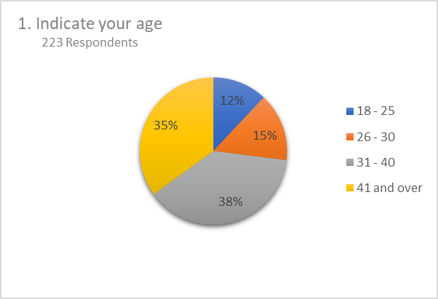

The pie chart above displays information about the respondents age group which helps to in determine the farmer’s mentality towards the use of Morden day equipment as young farmers have a high probability of using technology such as smart phones to order equipment and the learning curve to new methods and systems. The chart shows that the first majority were middle aged farmers aged between 31 – 40 years old at 38% then the 2nd majority where mature farmers of 41 years and over at 35% then followed by the youth at 15% and lastly the young adults at 12%. It might take a lot of software support and training to get the users to use the system effortlessly.

Figure 2 Respondent’s gender representation

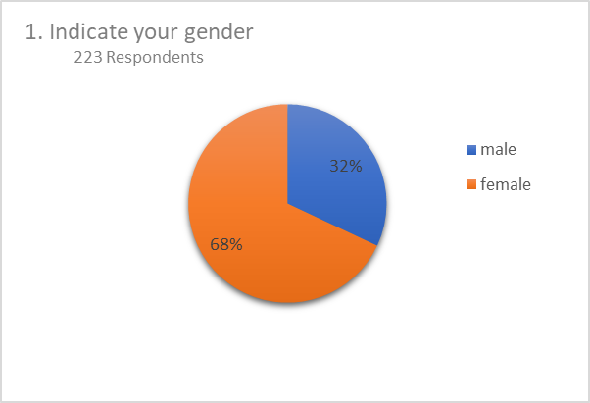

The next chart displays information about gender of the respondents which helps to determine the demographic attitudes towards using the system and which gender participates more in farming for marketing purposes. The chart shows that about 32% where Males and 68% were Females.

Figure 3 Type of farmer representation

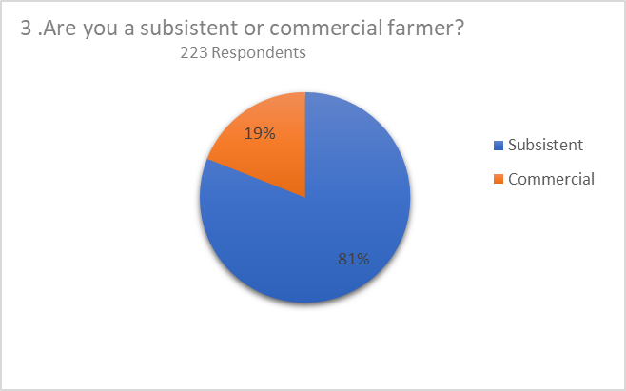

This chart shows that about 81% are subsistent farmers while 19% are commercial farmers, the objective of this question was to identify what type of farmer the participant is.

Figure 4 Respondent’s experience representation

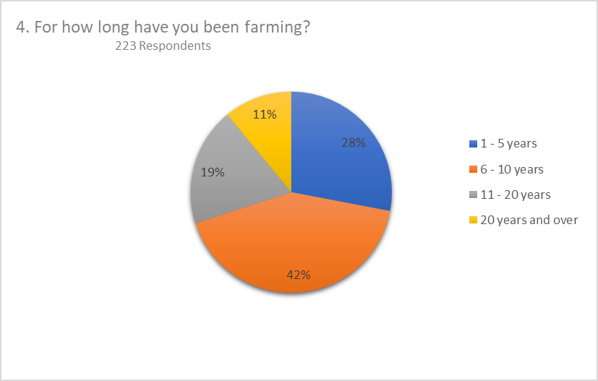

The objective of this question was to determine the amount of experience the farmer has had in the field. And if they have been using the same method of farming for the period the participant has been farming. The findings where that 28% have an experience of 1 – 5 years, lowwowed by 42% who have an experience of 6 – 10 years then 19% that have an experience if 11 – 20 years and lasltly 11% have an experience of more than 20 years

Figure 5 Respondents farming methodology representation

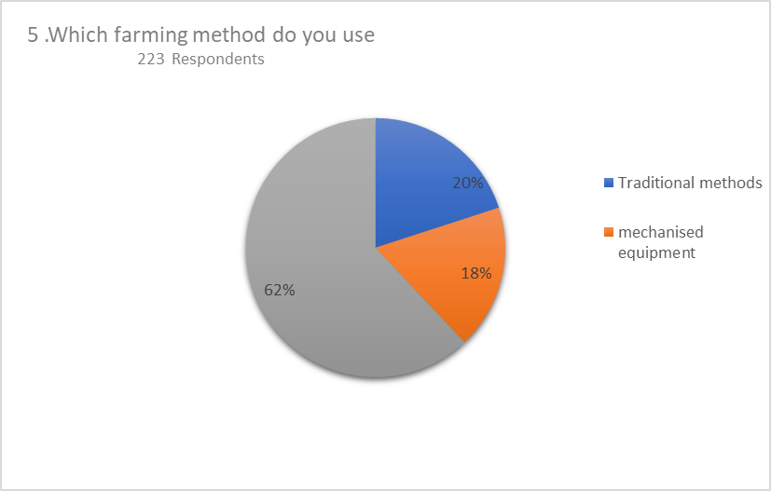

This chart show that 62% of farmers use both subsistent and comercial farming while 18% use mechanised equipment and 20% use traditional methods

Figure 6 Respondent’s method satisfaction representation

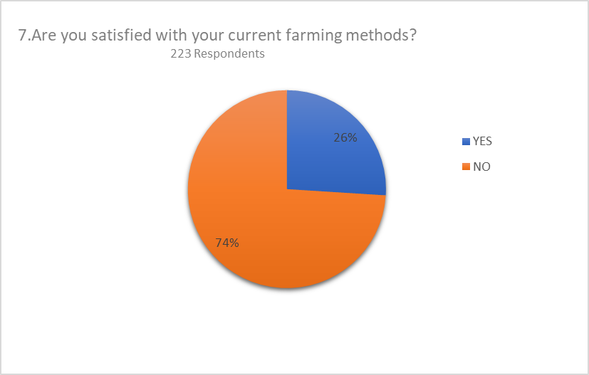

The objective of the question was to assess how satisfied the farmers were with their current method of farming. 74% were not satisfied while 26% were.

Figure 7 respondents methodology preference representation

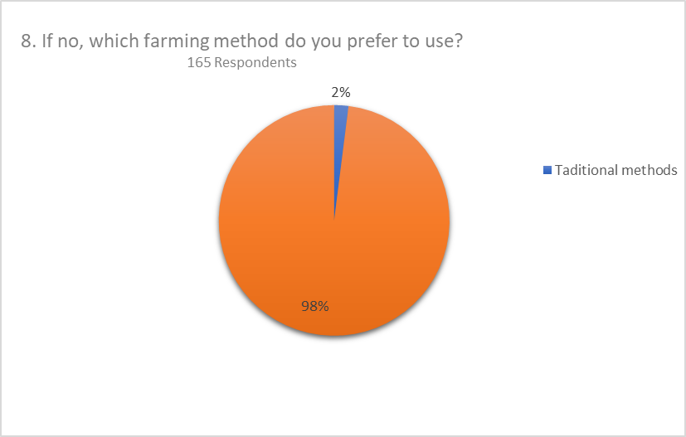

The majority of the respondents preferred to use mechanised methods of farming which is 98% of respondents while the remaining 2% preferred to stick to the traditional method

Figure 8 Respondent’s attitude to new system representation

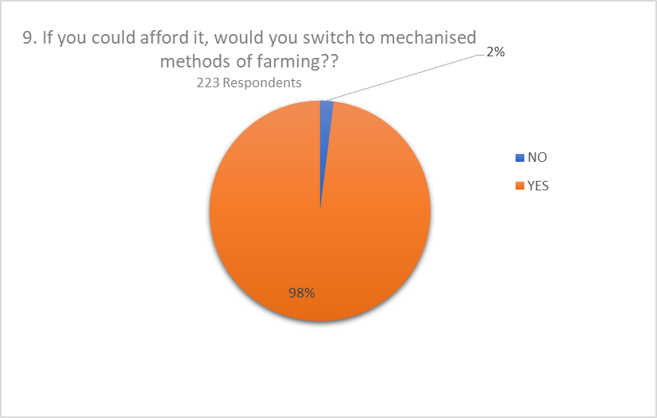

The majority of the respondents preferred to switch to mechanised methods of farming which is 98% of respondents while the remaining 2% preferred to stick to the traditional method

Figure 9

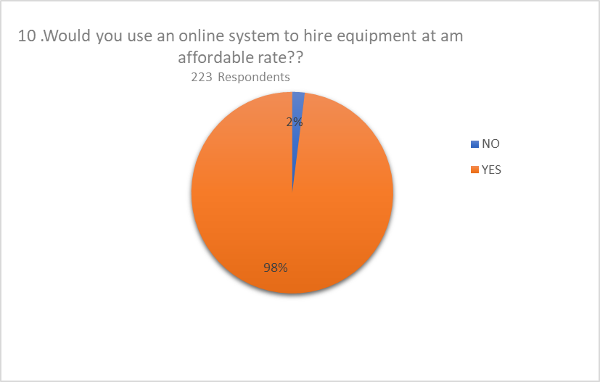

98% of respondents are willing to use the system while the remaining 2% preferred not to.

**5.2 System Platform and Requirements**

A study was carried out to gain an understanding of the farmers and current system and problems experienced in this system through observations and questionnaires. The findings obtained will be used to determine the viability of the system being proposed in terms of technical feasibility.

Visual studio code was the ide used to develop the web app and the programming language that was used for functions was JavaScript. For the user interface elements HTML and a free open-source CSS framework were used for the structure and styling, Bootstrap is on board and is concerned with the web app theme a design. Presenting a new ecommerce website project in PHP were used for front-end development.

MySQL manages the web apps database along with XAMPP. MySQL is an open-source relational database management system (RDBMS) that relies on SQL (structured query language). Web-based applications use Relational Data Base Management Systems for its development. MySQL helps you structure your data, present the information in an organized manner, edit, delete, update, or retrieve data whenever required.

XAMPP is a cross-platform compatible Apache distribution. MySQL also works on multiple operating systems and it can easily integrate with PHP. On XAMPP MySQL works as a database component which is required to run a database-enabled website and servers. On the control panel of XAMPP MySQL and Apache need to be started first in order to run the website on the local server. As shown in the see the figure below. And when you see their status turned into green that means it has been started correctly.

Figure 10 xampp screenshot



**5.2.1 Functional Requirements**

At this stage, user requirements and system specifications were gathered. Which led to functional and non-functional requirements, programming language to use, database model and hardware specifications

**Customer Login/Register**

This module allows a user to register as a new customer and allows a user to login if they already have an account. After a customer logs in or registers their accounts. He/she can view available products and add products to their cart with a certain quantity.

**Admin Panel**

Allows the administrator to view all orders, manage product lists, their categories and view total customers with their details.

It also allows the administrator add a product, he/she must provide a suitable product name by selecting a name, category and should enter a description, quantity, amount, and product image too.

It allows the administrator to check the order status of the customer with their respective product names.

**Add-To-Cart module**

Allows the users to add items into their cart for hire

**Product categories**

Enables the system to display the different categories of farming equipment available for hire

**Payment module**

Allows the farmer to make payments for the equipment he/she wishes to hire

**View customer’s order details**

Allows the admin to view the orders the farmers have made

**Product management module**

Allows the administrator to add, edit and delete a product from the system

**5.2.2 Non-functional Requirements**

* Security- the system provides privacy and will not share any information with any third parties without their consent.
* Usability- the application is user friendly, readable texts and labels and easy to use navigation system.
* Scalability- the system has enough room for growth, extensions or features and updates
* Reliability- the system will be up and running twenty-four hours a day seven days a week

# **5.2.3 Hardware Requirements**

* Processor: AMD, Apple, ARM, Centaur Technology, Integrated Device Technology (IDT), Intel, Samsung, Acer
* Minimum RAM 4 GB
* System type 64-bit operating system, x64-based processor
* Minimum Storage 20GB

# **5.2.4 Software Requirements**

* Windows 8, 10 and 11
* Linux
* Browsers - Chrome, Mozilla Firefox, Microsoft edge, Safari
* An internet connection of at least 2mbps

# **5.2.5 System Development methodology**

Agile methodology was used hand in hand with the iterative and incremental development methodology.

**Agile methodology**

Agile incremental and iterative development methodology is a chain of rapid development and deployment. It involves 6 stages namely;

Figure 11 Agile methodology

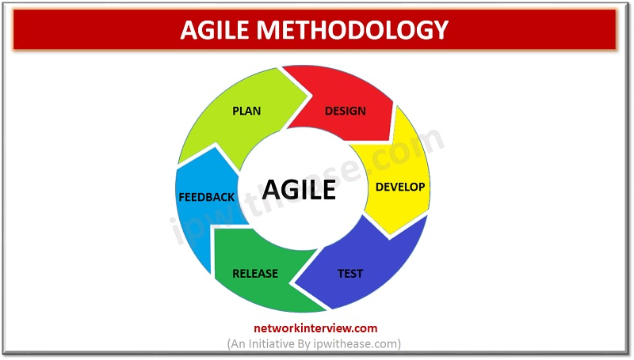

1. **Planning**

This involves gathering user, system and business requirements before the developers starts to develop the project. Initial documentation is also generated containing the system analysis and design specifications, project chatter and overall system requirements (Janani, 2021)

1. **Design**

One or more designs are created to achieve project results. Tools used to create results include dioramas, flow-charts, sketches, site trees, HTML screen designs, photo impressions, prototypes, and UML schemas. (Coastal media brand, 2021)

1. **Develop**

In this phase the project is broken down into small modules and coding begins to take place, after a module has been developed other modules are built on top of the previous modules incrementally. This stage is simply translating the design documentation into the product software and is the most time-consuming stage of the development process because it the foundation of the entire process. (Janani, 2021)

1. **Testing**

After development, the system is tested for defects, errors, regression testing functionality testing user acceptance testing then debugging and corrective measures take place. The test is done manually or using automated testing tools (kumar, 2021) and after ensuring that every component works fine, it goes to the next stage. If changes are made or the system has not been developed according the design specification, the process goes back to the previous stages until the system meets the requirements in the planning phase or new requirements.

1. **Release**

The program is installed on the servers and made available to farmers for use. At this stage deployment will take place and the software will go live accessible to users online via a link

1. **Feedback**

A customer review of the system is given by users, monitoring and observation of the system is done, a helpdesk is set up, user manual training, final documentation and quality assurance activities are implemented.

Figure 12 iterative and incremental methodology

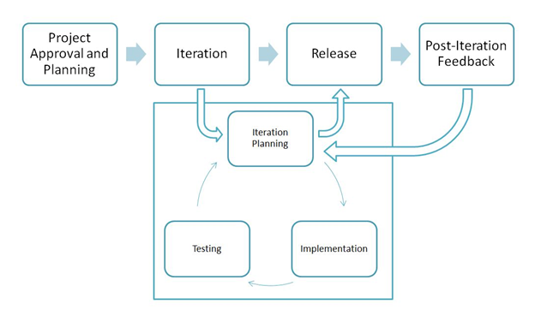

In iterative and incremental development, it is known to be a design methodology that is based on a cyclical process and it runs in an organized manner. The steps involved in the cycle are project planning, iteration and under iteration are iteration planning, testing, and implementation, as well as refining a product or a process, then finally release and post iteration feedback.

A particular project or software is broken down into a variety of iterations in which each of the iterations is a complete development loop resulting in a release of the product or software to be executed. Thus, the final product that is delivered has grown from iteration to iteration to become a final product or software.

# **5.2.6 System design**

Some of the examples of graphical modelling languages are  
  
Unified Modelling Language (UML): To describe software both structurally and behaviourally with graphical notation.  
  
1. Flowchart: A schematic or stepwise representation of an algorithm.  
  
2. Business Process Modelling Notation (BPMN): Used for Process Modelling language.  
  
3. Systems Modelling Language (SysML): Used for systems engineering.  
  
**Design methods:**   
  
1) Architectural design: To describe the views, models, behaviour, and structure of the system.  
2) Logical design: To represent the data flow, inputs and outputs of the system. Example: ER Diagrams (Entity Relationship Diagrams).

3) Physical design: Defined as

a) How users add information to the system and how the system represents information back to the user.

b) How the data is modelled and stored within the system.

c) How data moves through the system, how data is validated, secured and/or transformed as it flows through and out of the system.

In this case the researcher will use both logical and physical system design methods, using the flow chart, use case diagram and the entity relationship scheme

# **5.2.6.1 Flow Chart Diagram**

A flowchart is a graphically representation of the structure of process or system, algorithm or the step-by-step solution of the problem. The Flowchart describes the flow of data through an information processing system and the parts of the flows. The flow represents a set of logic operations that meet the certain requirements.

A Flowchart allows to see how the work of the process can be improved, allows to find the key elements of the process and detach the steps that are not essential or even excessive.

Figure 13 farmer side flow chart

Checkout

No

Yes

Yes

Yes

Yes

Place Order

Order Review

Login

Add payment I

n

fo

Logged Out

Registered?

View Items to Cart

Update Request

Checkout

Add

Items to Cart

Yes

Launch App

View Menu

Add delivery address

Change

Request?

Sign up

Figure 14 Admin side flow chart

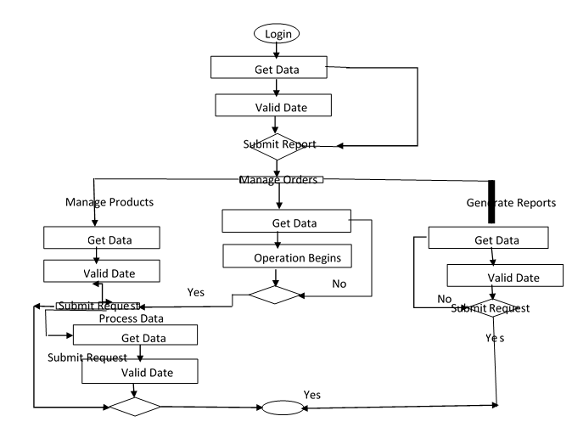

rectangle - flowchart process step

One step in the process. The step is written inside the box. Usually, only one arrow goes out of the box.

Direction of flow from one step or decision to another.

diamond - flowchart decision step

 Decision based on a question. The question is written in the diamond. More than one arrow goes out of the diamond, each one showing the direction the process takes for a given answer to the question. (Often the answers are "yes" and "no.")

rounded rectangle or oval - flowchart start and end points

Alternate symbols for start and end points

# **5.2.6.2 Relationship Schema**

Entity Relationship Diagram / Schema, also known as ERD, ER Diagram or ER model, is a type of structural diagram for use in database design. An ERD contains different symbols and connectors that visualize two important information: The major entities within the system scope, and the inter-relationships among these entities.

ERD helps database design. By drawing ER diagrams to visualize database design ideas, you have a chance to identify the mistakes and design flaws, and to make corrections before executing the changes in the database.

It also helps requirements gathering – by determining the requirements of an information system through drawing a conceptual ERD that depicts the high-level business objects of the system. Such an initial model can also be evolved into a physical database model that aids the creation of a relational database, or aids in the creation of process maps and data flow modes.

Figure 15 Entity relationship schema

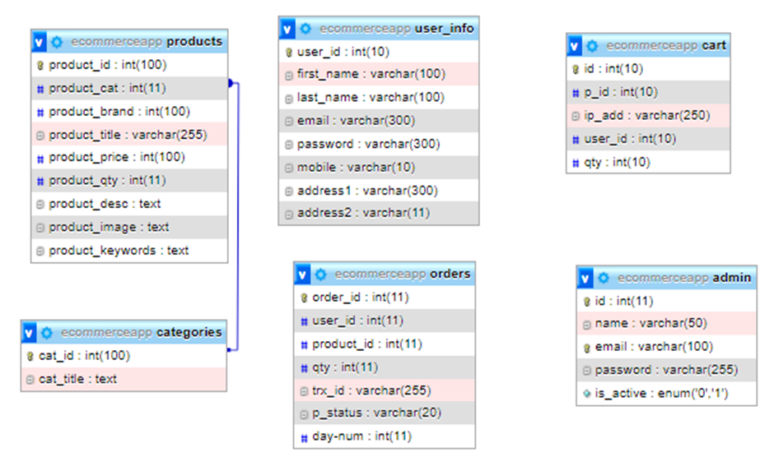

* + - 1. **Use Case Diagram**

A use case diagram summarizes the details of your system's users (also known as actors) and their interactions with the system. It uses a set of specialized symbols and connectors. An effective use case diagram can help your team discuss and represent scenarios in which your system or application interacts with people, organizations, or external systems and Goals that your system or application helps those entities (known as actors) achieve

Figure 16 Use case diagram

Sign In

View

Admin

User

Sign In

Sign Up

Make request

H

i

Select Equipment

Update Request

Sign out

# **CHAPTER SIX - IMPLEMENTATION**

# **6.0 Introduction**

 This web app contains a navigation bar where a user can log in, register, view cart, search for products and go back home.

It displays all the product categories on the left side of the web site while the catalogue is shown on the right. The project is divided into two categories which are the farmer Login and Admin Login, the admin has full control of the site. The admin is authorized to view all orders, manage product lists, their categories with brand names, and view total customers with their details. In order to add a product, an admin must provide a suitable product name by selecting a brand name, category and should enter a description, quantity, amount, and product image too. The admin can also check the order status of the customer with their respective product names and transaction id.

The farmer on the other hand only interacts with the front-end side and can log in or register their accounts. He/she can view available products and add products to their cart with a certain quantity. After all, the customer can continue to checkout to make a payment

The tools that have been used in the development and implementation of the system are open-source frameworks such as bootstrap etc.

# **6.1 System Coding**

**Environment set up**

Visual studio code was downloaded and a couple of extensions were downloaded too such as prettier and ES7.

The researcher installed both NodeJS which is a JavaScript runtime environment built on a chrome Engine which helps run JavaScript on a server, and npm. Webpack a module bundler, which helps to handle the project in a very clean and non-confusing way in huge projects that have multiple .js files, .html files & multiple .css files and are all interlinked to each other was also downloaded. After all environment variables were set up the researcher moved on to developing the system modules

**Customer and admin Login/Register**

This module allows a user to register as a new farmer and allows a user to login if they already have an account. After a customer log in or registers their accounts. He/she can view available products and add products to their cart with a certain quantity.

The php and java script login files for the farmer and admin are in two separate folders whereas the farmer would require admin access to view, modify add or dele any data that is only authorized by the admin

The login form is available in the index.php page. Input data is sent to login.php page, if you get login success string from login.php page means user is logged in successfully and window. Location is used to redirect the user.

Here is a snippet of the customer login function;

    $("#login").on("submit",function(event){

        event.preventDefault();

        $(".overlay").show();

        $.ajax({

            url :   "login.php",

            method: "POST",

            data    :$("#login").serialize(),

            success :function(data){

                if(data == "login_success"){

                    window.location.href = "profile.php";

                }else if(data == "cart_login"){

                    window.location.href = "cart.php";

                }else{

                    $("#e_msg").html(data);

                    $(".overlay").hide();

                }

            }

        })

    })

**Admin Panel**

Allows the administrator to view all orders, manage product lists, their categories and view total customers with their details.

It also allows the administrator add a product, he/she must provide a suitable product name by selecting a name, category and should enter a description, quantity, amount, and product image too.

It allows the administrator to check the order status of the customer with their respective product names.

Here is a snippet of the admin log in function

$(".login-btn").on("click", function(){

        $.ajax({

            url : '../admin/classes/Credentials.php',

            method : "POST",

            data : $("#admin-login-form").serialize(),

            success : function(response){

                console.log(response);

                var resp = $.parseJSON(response);

                if (resp.status == 202) {

                    $("#admin-register-form").trigger("reset");

                    //$(".message").html('<span class="text-success">'+resp.message+'</span>');

                    window.location.href = window.origin+"/ecommerce-app-h/admin/index.php";

                }else if(resp.status == 303){

                    $(".message").html('<span class="text-danger">'+resp.message+'</span>');

                }

            }

        });

    });

**Add-To-Cart module**

This module allows the users to add items into their cart for hire below is a snippet for add product to cart function. This snippet is found on the customer or farmer side of the project.

$("body").delegate("#product","click",function(event){

        var pid = $(this).attr("pid");

        event.preventDefault();

        $(".overlay").show();

        $.ajax({

            url : "action.php",

            method : "POST",

            data : {addToCart:1,proId:pid},

            success : function(data){

                count_item();

                getCartItem();

                $('#product_msg').html(data);

                $('.overlay').hide();

            }

        })

    })

**View customer’s order details**

Allows the admin to view the orders the farmers have made, view php snippet below.

<?php

                            include_once("db.php");

                            $user_id = $_SESSION["uid"];

                            $orders_list = "SELECT o.order_id,o.user_id,o.product_id,o.qty,o.trx_id,o.p_status,p.product_title,p.product_price,p.product_image FROM orders o, products p WHERE o.user_id='$user_id' AND o.product_id=p.product_id";

                            $query = mysqli_query($con,$orders_list);

                            if (mysqli_num_rows($query) > 0) {

                                while ($row=mysqli_fetch_array($query)) {

                                    ?>

                                        <div class="row">

                                            <div class="col-md-6">

                                                <img style="float:right;" src="product_images/<?php echo $row['product_image']; ?>" class="img-responsive img-thumbnail"/>

                                            </div>

                                            <div class="col-md-6">

                                                <table>

                                                    <tr><td>Product Name</td><td><b><?php echo $row["product_title"]; ?></b> </td></tr>

                                                    <tr><td>Product Price</td><td><b><?php echo  CURRENCY." ".$row["product_price"]; ?></b></td></tr>

                                                    <tr><td>Quantity</td><td><b><?php echo $row["qty"]; ?></b></td></tr>

                                                    <tr><td>Transaction Id</td><td><b><?php echo $row["trx_id"]; ?></b></td></tr>

                                                </table>

                                            </div>

                                        </div>

                                    <?php

                                }

                            }

                        ?>

**Product management module**

Allows the administrator to add, edit and delete a product from the system. In this module the developer will show a snippet of add product which is found in the admin folder

$(".add-product").on("click", function(){

        $.ajax({

            url : '../admin/classes/Products.php',

            method : 'POST',

            data : new FormData($("#add-product-form")[0]),

            contentType : false,

            cache : false,

            processData : false,

            success : function(response){

                console.log(response);

                var resp = $.parseJSON(response);

                if (resp.status == 202) {

                    $("#add-product-form").trigger("reset");

                    $("#add_product_modal").modal('hide');

                    getProducts();

                    // window.location.href = "index.php";

                    //window.location = '../admin/classes/Products.php';

                }else if(resp.status == 303){

                    // window.location.href = "products.php";

                    alert(resp.message);

                }

            }

        });

    });

* 1. **Backend Database**

1. CREATE TABLE `admin` (
2. `id` int(11) NOT NULL,
3. `name` varchar(50) NOT NULL,
4. `email` varchar(100) NOT NULL,
5. `password` varchar(255) NOT NULL,
6. `is_active` enum('0','1') NOT NULL DEFAULT '0'
7. ) ENGINE=InnoDB DEFAULT CHARSET=latin1;
8. --
9. -- Dumping data for table `admin`
10. --
11. INSERT INTO `admin` (`id`, `name`, `email`, `password`, `is_active`) VALUES
12. (5, 'test', 'test@gmail.com', '$2y$10$qZ0OoyX8bhAVxDFM/fx8leZSZwlyq15c1C/KTnaqDLSx6eCDJ0VpC', '0'),
13. (8, 'demo, 'demo@gmail.com', '$2y$10$YKSDtra7v2wH6ORYfry8Ue9t49pk1AvQvdJGuq4lDvFLEcx.kP6Mq', '0');
14. -- --------------------------------------------------------
15. --
16. -- Table structure for table `cart`
17. --
18. CREATE TABLE `cart` (
19. `id` int(10) NOT NULL,
20. `p_id` int(10) NOT NULL,
21. `ip_add` varchar(250) NOT NULL,
22. `user_id` int(10) DEFAULT NULL,
23. `qty` int(10) NOT NULL
24. ) ENGINE=InnoDB DEFAULT CHARSET=latin1;
25. --
26. -- Dumping data for table `cart`
27. --
28. INSERT INTO `cart` (`id`, `p_id`, `ip_add`, `user_id`, `qty`) VALUES
29. (1, 4, '::1', 4, 1);
30. -- --------------------------------------------------------
31. --
32. -- Table structure for table `categories`
33. --
34. CREATE TABLE `categories` (
35. `cat_id` int(100) NOT NULL,
36. `cat_title` text NOT NULL
37. ) ENGINE=InnoDB DEFAULT CHARSET=latin1;
38. --
39. CREATE TABLE `orders` (
40. `order_id` int(11) NOT NULL,
41. `user_id` int(11) NOT NULL,
42. `product_id` int(11) NOT NULL,
43. `qty` int(11) NOT NULL,
44. `trx_id` varchar(255) NOT NULL,
45. `p_status` varchar(20) NOT NULL
46. ) ENGINE=InnoDB DEFAULT CHARSET=latin1;
47. INSERT INTO `orders` (`order_id`, `user_id`, `product_id`, `qty`, `trx_id`, `p_status`) VALUES
48. (1, 1, 1, 1, '9L434522M7706801A', 'Completed'),
49. (2, 1, 2, 1, '9L434522M7706801A', 'Completed'),
50. (3, 1, 3, 1, '9L434522M7706801A', 'Completed'),
51. (4, 1, 1, 1, '8AT7125245323433N', 'Completed');
52. -- --------------------------------------------------------
53. --
54. -- Table structure for table `products`
55. --
56. CREATE TABLE `products` (
57. `product_id` int(100) NOT NULL,
58. `product_cat` int(11) NOT NULL,
60. `product_title` varchar(255) NOT NULL,
61. `product_price` int(100) NOT NULL,
62. `product_qty` int(11) NOT NULL,
63. `product_desc` text NOT NULL,
64. `product_image` text NOT NULL,
65. `product_keywords` text NOT NULL
66. ) ENGINE=InnoDB DEFAULT CHARSET=latin1;
67. --
68. -- Dumping data for table `products`
69. --
70. -- --------------------------------------------------------
71. --
72. -- Table structure for table `user_info`
73. --
74. CREATE TABLE `user_info` (
75. `user_id` int(10) NOT NULL,
76. `first_name` varchar(100) NOT NULL,
77. `last_name` varchar(100) NOT NULL,
78. `email` varchar(300) NOT NULL,
79. `password` varchar(300) NOT NULL,
80. `mobile` varchar(10) NOT NULL,
81. `address1` varchar(300) NOT NULL,
82. `address2` varchar(11) NOT NULL
83. ) ENGINE=InnoDB DEFAULT CHARSET=latin1;
84. --
85. --
86. ALTER TABLE `admin`
87. ADD PRIMARY KEY (`id`),
88. ADD UNIQUE KEY `email` (`email`);
89. --
90. --
91. --
92. ALTER TABLE `cart`
93. ADD PRIMARY KEY (`id`);
94. --
95. -- Indexes for table `categories`
96. --
97. ALTER TABLE `categories`
98. ADD PRIMARY KEY (`cat_id`);
99. --
100. -- Indexes for table `orders`
101. --
102. ALTER TABLE `orders`
103. ADD PRIMARY KEY (`order_id`);
104. --
105. -- Indexes for table `products`
106. --
107. ALTER TABLE `products`
108. ADD PRIMARY KEY (`product_id`),
109. ADD KEY `fk_product_cat` (`product_cat`),
110. --
111. -- Indexes for table `user_info`
112. --
113. ALTER TABLE `user_info`
114. ADD PRIMARY KEY (`user_id`);
115. --
116. -- AUTO_INCREMENT for dumped tables
117. --
118. --
119. -- AUTO_INCREMENT for table `admin`
120. --
121. ALTER TABLE `admin`
122. MODIFY `id` int(11) NOT NULL AUTO_INCREMENT, AUTO_INCREMENT=9;
123. --
124. --
125. -- AUTO_INCREMENT for table `cart`
126. --
127. ALTER TABLE `cart`
128. MODIFY `id` int(10) NOT NULL AUTO_INCREMENT, AUTO_INCREMENT=2;
129. --
130. -- AUTO_INCREMENT for table `categories`
131. --
132. ALTER TABLE `categories`
133. MODIFY `cat_id` int(100) NOT NULL AUTO_INCREMENT, AUTO_INCREMENT=15;
134. --
135. -- AUTO_INCREMENT for table `orders`
136. --
137. ALTER TABLE `orders`
138. MODIFY `order_id` int(11) NOT NULL AUTO_INCREMENT, AUTO_INCREMENT=5;
139. --
140. -- AUTO_INCREMENT for table `products`
141. --
142. ALTER TABLE `products`
143. MODIFY `product_id` int(100) NOT NULL AUTO_INCREMENT, AUTO_INCREMENT=21;
144. --
145. -- AUTO_INCREMENT for table `user_info`
146. --
147. ALTER TABLE `user_info`
148. MODIFY `user_id` int(10) NOT NULL AUTO_INCREMENT, AUTO_INCREMENT=7;
149. --
150. -- Constraints for dumped tables
151. --
152. --
153. -- Constraints for table `products`
154. --
155. ALTER TABLE `products`
156. ADD CONSTRAINT `fk_product_cat` FOREIGN KEY (`product_cat`) REFERENCES `categories` (`cat_id`);

# **CHAPTER SEVEN - TESTING**

# **7.0 Introduction**

The purpose of the system testing is to consider all the likely variations to which it will be suggested and push the systems to limits.

The testing process focuses on the logical intervals of the software ensuring that all statements have been tested and on functional interval is conducting tests to uncover errors and ensure that defined input will produce actual results that agree with the required results. Program level testing, modules level testing integrated and carried out. There are two major type of testing they are 1. White Box Testing.

2. Black Box Testing.

White Box Testing

White box sometimes called “Glass box testing” is a test case design that uses the control structure of the procedural design to drive test case.

Using white box testing methods, the following tests were made on the system

1. All independent paths within a module have been exercised once. In our system, ensuring that case was selected and executed checked all case structures. The bugs that were prevailing in some part of the code where fixed
2. All logical decisions were checked for the truth and falsity of the values.

Black box Testing

Black box testing focuses on the functional requirements of the software. This is black box testing enables the software engineering to derive a set of input conditions that will fully exercise all functional requirements for a program. Black box testing is not an alternative to white box testing rather it is complementary approach that is likely to uncover a different class of errors that white box methods like..

1. Interface errors
2. Performance in data structure
3. Performance errors
4. Initializing and termination errors

The project is meant to satisfy the needs of rental house owners. Several user friendly interfaces have also been adopted. This package shall prove to be a powerful in satisfying all the requirements of the users

It is with utmost faith that I present this software to you hoping that it will solve your problems and encourage you to continue appreciating technology because it is meant to change and ease all our work that seems to be very difficult. The project is not at its best however, I would encourage anyone who has the ability to advance it using advanced technologies so as to increase its capabilities.

**. Unit testing:** It is the best test performed on individual events or modules of a program. In other words, it is the testing of an isolated subset of a program. Basically, unit testing is typically carried out by the developer.

**b. Integration testing:** In this testing phase, different modules are combined and tested as a group to make sure that the integrated system is ready for system testing. The test is done under the supervision of designers.

**c. System testing:** is performed on a complete, integrated system. This test is done in the presence of an analyst, designer, and representative.

**2. System Acceptance Testing:** A system acceptance testing is a final system to accept or reject the system. It is an extensive test that addresses the following levels of acceptance testing:

**a. Verification testing:** runs the system in a simulated environment using simulated data. This is sometimes called alpha testing.

**b. Validation testing:** runs the system in a live environment using real data. This is sometimes called beta testing.

**c. Audit testing:** certifies that the system is free of errors and is ready to be placed into operation.

**3. Installation Testing:** To make sure that product/software can be installed on a specific or support defined system, can be configured, and can be brought into an operational mode. It includes **–**

**a. Functionality testing:** To make sure that the functionality of products is working as per the requirements defined, within the capabilities of the system.

**b. Recoverability testing:** To make sure how well the system recovers from various input errors and other failure situations.

**c. Interoperability testing:** To make sure whether the system can operate well with third-party products or not.

**d. Robustness system testing:** Robustness testing is designed to verify how sensitive a system is toward an error input or how the system behaves in error situations and in a changing operational

**Performance testing:** To make sure the system’s performance under various conditions, in terms of performance characteristics:

**a. Scalability testing:**To make sure systems scaling abilities in various terms like under scaling, geographic scaling, and resource scaling.

**b. Reliability testing:** To make sure the system can be operated for a longer duration without developing failures.

**c. Regression testing:** To make sure that new functionalities added into the system do not break the existing functionalities.

**d. Stress testing:** This testing generally checks whether the system is going to continue to function when subjected to a large volume of data than expected.

**e. Load and stability testing:** To test that the system is capable enough to withstand expected load without breaking down. This testing determines, how the application behaves when multiple users access it simultaneously across multiple locations.

**5. Documentation Testing:** to make sure that the systems user guide and manual are correct, complete, and usable. It includes **–**

**a. Security testing:** to make sure that the system does not allow unauthorized access to data and resources.

**b. Usability testing:** to make sure that the system is user-friendly, easy to use, learn & operate.

# **CHAPTER EIGHT - CRITICAL EVALUATION**

# **8.0 Introduction**

In this chapter, all the limitations of the study will be explained, whilst highlighting the benefits of system that has been developed. This will provide data and information to anyone planning to undergo a research and project in this knowledge field.

# **8.1 Limitations**

**Payment and orders module**

The payment module could not be fully and successfully completed because of a financial constraint. The orders module depends on the success of the payment module. In order to view real time orders, the external mobile money or banks or 3rd parties are responsible for creating the transaction between the farmer and the lessor. The customer id , transaction id, product details and total amount is meant to be populated in the database and sent to the orders page. View payment_success.php in the code or see the snippet below.

The 3rd party financial mediators such as Airtel money, Momo money Zamtel money and alike, develop APIs which are supposed to be integrated with the system but for the APIs to function, the developer has to pay for a premium or production mode.

For demonstration purposes the researcher manually populated order information in the database.

<?php

session_start();

if(!isset($_SESSION["uid"])){

    header("location:index.php");

}

if (isset($_GET["st"])) {

    # this is where the production mode API is supposed to sit

    $trx_id = $_GET["tx"];

        $p_st = $_GET["st"];

        $amt = $_GET["amt"];

        $cc = $_GET["cc"];

        $cm_user_id = $_GET["cm"];

        $c_amt = $_COOKIE["ta"];

    if ($p_st == "Completed") {

        include_once("db.php");

        $sql = "SELECT p_id,qty FROM cart WHERE user_id = '$cm_user_id'";

        $query = mysqli_query($con,$sql);

        if (mysqli_num_rows($query) > 0) {

            # code...

            while ($row=mysqli_fetch_array($query)) {

            $product_id[] = $row["p_id"];

            $qty[] = $row["qty"];

            }

// After payment is successful, the orders information is supposed to be posted in the database via sql like shown below

            for ($i=0; $i < count($product_id); $i++) {

                $sql = "INSERT INTO orders (user_id,product_id,qty,trx_id,p_status) VALUES ('$cm_user_id','".$product_id[$i]."','".$qty[$i]."','$trx_id','$p_st')";

                mysqli_query($con,$sql);

            }

# **8.2 Benefits**

# **CHAPTER NINE - CONCLUSIION**

The fundamental goal of the research work is to design a web based hiring system based on the available technology for farmers to hire machines with flexibility and ease at their convenience and at a lower price rate. The new system made use of well secured, optimized and structured database management system for proper storing and retrieval of information. The capabilities of the system are user friendly; the database is capable of storing and retrieving farmers’ information quickly. In conclusion, the implementation of this work by any farming association or farmers nationwide as a means of hiring machines would enhance the quality and productivity of their farming and harvest. The author invites other researchers and developers to carry on the where she has left off, make further adjustments or additions to this project to assist academic students, researchers and farmers.

# **References.**

Ray, D. K., Mueller, N. D., West, P. C., & Foley, J. A. (2013). Yield Trends Are Insufficient to Double Global Crop Production by 2050. ONE, 8(6), e66428.

Godfray, H. C. J., Beddington, J. R., Crute, I. R., Haddad, L., Lawrence, D., Muir, J. F., Toulmin, C. (2010). Food Security: The Challenge of Feeding 9 Billion People. Science, 327(5967), 812–818.

Licker, R., Johnston, M., Foley, J. A., Barford, C., Kucharik, C. J., Monfreda, C., & Ramankutty, N. (2010). Mind the gap: how do climate and agricultural management explain the “yield gap” of croplands around the world? Global Ecology and Biogeography, 19(6), 769–782.

Ajah, J. (2014). Factors Limiting Small-Scale Farmers’ Access and Use of Tractors for Agricultural Mechanization in Abuja, North Central Zone, Nigeria. European Journal of Sustainable Development vol. 3 (1) 115-124.

WEF-World Bank-OECD. (2015). Africa Competitiveness Report Geneva

OECD-FAO., (2014). OECD-FAO Agricultural Outlook, Paris: OECD

Aguilera, E., Guzman, G. I., González de Molina, M., Soto, D., & Infante-Amate, J. (2019). From animals to machines. The impact of mechanization on the carbon footprint of traction in Spanish agriculture: 1900–2014. Journal of Cleaner Production Vol. 221; 295 – 305.

Azeta, J., Bolu, C. A., Alele, F., Daranijo, E. O., Onyeubani, P., Abioye, A. A. (2019). Application of Mechatronics in Agriculture: A review. Journal of Physics: Conference Vol. 1378 (3).

Tyagi, A., Gupta, N., Navani, J. P., Tiwari, M. R., & Gupta, M. A. (2017). Smart irrigation system. International Journal for Innovative Research in Science & Technology, 3(10).

Ramli, N. L., Mohd Yamin, N., Ab Ghani, S., Saad, N. M., & Md Sharif, S. (2015). AI implementation of passive infrared sensor in street lighting automation system. ARPN Journal of Engineering and Applied Sciences, 10(22), 17120–17126.

Hessel, L., Bar-On, D. (2003). U.S. Patent No. 6,508,033. Washington, DC: U.S. Patent and Trademark Office

Srinivas K. R. (2018). Cooperation in Agriculture in AAGC: Innovations and Agro Processing. RIS/AAGC-DP vol. 221.

Arogundade, O.T., Abayomi-Alli, A., Adesemowo, K., Bamigbade, T., Odusami, M. And Olowe, V., (2020). An Intelligent Market space Mobile Application for Marketing Organic

Products. In Responsible Design, Implementation and Use of Information and Communication Technology. I3E 2020. Lecture Notes in Computer Science (Vol. 12066, pp. 276–287). Springer, Cham.

Takeshima, H., Hatzenbuehlerb. P.L., Edeh, H.O. (2020). Effects of agricultural mechanization on economies of scope in crop production in Nigeria. Agricultural Systems 177 (102691).

15. Matiyabu, I., I., Ndayizigamiye, P. (2019). Enhancing Agricultural Practices through Mobile Technology Interventions: A Case of the Democratic Republic of Congo. IEEE Global Humanitarian Technology Conference (GHTC).

Pongsuwan, W., Pongsuwan, H. (2019). Social Media for Smart Farmer-Shared Farming

Equipment Model. Information Management and Business Review, Vol. 11(2), 1-9.

Hassan, F., & Kornher, L. (2019). let’s get mechanized – labor market implications of structural transformation in Bangladesh pp. 1-26.

Sims, B.G., Hilmi, M., Kienzle, J. (2016). Agricultural mechanization: a key input for sub-Saharan Africa smallholders. FAO, Rome (Italy). Plant Production and Protection Div.23.

Bello, R., S., Onyeanula P., Saidu, M., J., Bello, M., B. (2015). Mechanization and Agricultural Productivity Functions in Umuahia North LGA, Abia, Nigeria. Science Journal of Business and Management. Vol 3(5-1) 21-25.

Verma, S. R. "Impact of agricultural mechanization on production, productivity, cropping intensity income generation and employment of labor." Status of farm mechanization in India (2006): 133-153.

Jonathan O., Ogbunude C. Misra, S., (2018). Design and implementation of a Mobile-based personal digital assistant (MPDA), Communications in Computer and Information Science, 1031, pp. 15-28.

O. Misra, S., Ibanga E., Maskeliunas, R. Damasevicius, R., Ahuja (2019). Design and Implementation of a mobile webcast application with Google analytics and cloud messaging functionality. Journal of Physics Conference Series, 1235(1), 012023.

Abayomi-Zannu, T.P., Odun-Ayo, I. Tatama, B.F., Misra, S. (2020). Implementing a Mobile Voting System Utilizing Block chain Technology and Two-Factor Authentication in Nigeria. Lecture Notes in Network and Systems, 121, 857-872.

CFU, NFU, FAO. Lusaka, Zambia. 47 p. FAO, 2011. Hire services by farmers for farmers. By: Sims, B, Röttger, A & Mkomwa, S. Diversification Booklet 19. Rural Infrastructure and Agro-Industries Division. Food and Agriculture Organization of the United Nations. Rome, Italy.

FAO, 2012. E-vouchers in Zimbabwe: guidelines for agricultural input distribution. Emergency, Rehabilitation and Coordination Unit, Zimbabwe. Food and Agriculture Organization of the United Nations. Rome, Italy. Available at: http://www.fao.org/fileadmin/user_upload/emergencies/docs/Evoucher_Zimbabwe.pdf

Garrity, DP, Akinnifesi, FK, Ajayi, OC, Weldesemayat, SG, Mowo, JG, Kalinganire, A, Larwanou, M & Bayala, J. 2010. Evergreen agriculture: a robust approach to sustainable food security in Africa. Food Security 2(3): 197-214.

Johansen, C, Haque, ME, Bell, RW, Thierfelder, C & Esdaile, RJ, 2012. Conservation agriculture for small holder rainfed farming: opportunities and constraints of new mechanized seeding systems. Field Crops Research, 132:18-32. 14 June 2012.

Siegel, PB & Alwang, J, 2005. Poverty reducing potential of smallholder agriculture in Zambia; opportunities and constraints. Social Development Department, World Bank. Washington DC. Africa Region Working paper 85. Available at: <http://www.worldbank.org/afr/wps/wp85.pdf>.

Sims, BG, Thierfelder, C, Kienzle, J, Friedrich, T & Kassam, A, 2012. Development of the conservation agriculture equipment industry in sub-Saharan Africa. Applied Engineering in Agriculture 28(6):813-823. Thierfelder, C & Wall, PC. 2010. Rotation in conservation agriculture systems of Zambia : effects on soil quality and water relations. Expl Agric. 46(3):309-325.

World Agroforestry Centre, 2009. Creating an evergreen agriculture in Africa for food security and environmental resilience. World Agroforestry Centre, Nairobi. 24pp

Oluwagbemi, O., Adewumi A., Misra, S., Leon, M. (2020). MAFODKM: Mobile Application Framework for the management of Omics Data and Knowledge Mining. Journal of Physics Conference Series, 1566 (1), 012132.

Holz, H. J., Applin, A., Hagerman, B., Joyce, D., Purchase, H., & Reed, C. (2006). Research

Methods in computing. Working Group Reports on ITiCSE on Innovation and Technology in Computer Science Education - ITiCSE-WGR ’06.

26. Saunders, M.N.K., Lewis, P., Thorn hill, A. (2019). Understanding research philosophy and Approaches to theory development. In: Research Methods for Business Students, pp. 128–170. Pearson, Harlow

ACC. (2008). Global Food Shortage and Organised Crime. Retrieved August 27, 2012 from http://www.crimecommission.gov.au

Hood, Leroy. "Population Growth and Ecosystem Limits." N.P., n.d. Web. <http://www.paypervids.com/population-growth-ecosystems-limits/>.

BBC. (2011) Somalia food crisis reaching 'unimaginable proportions' Refugees. Retrieved August 27, 2012 from https://www.bbc.com/

Bourke, R. M., Allen, M. G and Salisbury J. G. (2000). Food security for Papua New Guinea: proceedings of the Papua New Guinea Food and Nutrition 2000 Conference. Retrieved August 27, 2012 from https://www.aciar.gov.au/

Kamdor, M. (2007).Climate change challenge for the poor, Yale global. Retrieved August 8, 2012 from, http://www.yaleglobal.yale.edu/

McDonald, M. A., Sigman, M., Michael, E. P., & Neumann, C. G. (nd). Impact of a Temporary Food Shortage on Children and Their Mothers. Retrieved August 27, 2012 from https://onlinelibrary.wiley.com/

UNU, (1998). Food shortage. Retrieved August 27, 2012 from https://archive.unu.edu/

Watson D, R. (nd) Testimony to the Financial Services Committee of the US House of Representatives. Retrieved August 27, 2012 from <http://www.agassessment.org>

Agriculture, M. o., n.d. *Country Commercial Guides.* [Online]   
Available at: https://www.trade.gov/country-commercial-guides/zambia-agriculture

Anon., 2021. *Zambia - Country Commercial Guide.* [Online]   
Available at: https://www.trade.gov/country-commercial-guides/zambia-agriculture

Coastal media brand, 2021. *Design Phase in SDLC.* [Online]   
Available at: https://coastalmediabrand.com/design-phase-in-sdlc-a-complete-guide-2021/#:~:text=What%20is%20the%20Design%20Phase%20in%20SDLC%3F%20The,designs%20are%20created%20to%20achieve%20the%20project%20result.  
[Accessed 08 02 2022].

GLG, 2022. *Rich Nelson.* [Online]   
Available at: https://glginsights.com/articles/russia-ukraine-and-the-impact-on-the-worlds-food-supply/

Janani, 2021. *Atatus.* [Online]   
Available at: https://www.atatus.com/glossary/agile-methodology/  
[Accessed 08 02 2022].

kumar, R., 2021. *Software Testing User manual.* [Online]   
Available at: https://www.softwaretestingmaterial.com/sdlc-software-development-life-cycle/  
[Accessed 08 02 2022].

Lusaka Times, 2021. *Lusakatimes.com.* [Online]   
Available at: https://www.lusakatimes.com/2021/08/23/why-is-zambias-agriculture-sector-failing-to-contribute-more-to-the-nations-gdp/  
[Accessed 08 02 2022].

WEF-World Bank-OECD, 2015. *Africa Competitiveness Report Geneva.* [Online].

Agriculture, M. o., n.d. *Country Commercial Guides.* [Online]   
Available at: https://www.trade.gov/country-commercial-guides/zambia-agriculture

Anon., 2021. *Zambia - Country Commercial Guide.* [Online]   
Available at: https://www.trade.gov/country-commercial-guides/zambia-agriculture

Coastal media brand, 2021. *Design Phase in SDLC.* [Online]   
Available at: https://coastalmediabrand.com/design-phase-in-sdlc-a-complete-guide-2021/#:~:text=What%20is%20the%20Design%20Phase%20in%20SDLC%3F%20The,designs%20are%20created%20to%20achieve%20the%20project%20result.  
[Accessed 08 02 2022].

GLG, 2022. *Rich Nelson.* [Online]   
Available at: https://glginsights.com/articles/russia-ukraine-and-the-impact-on-the-worlds-food-supply/

Janani, 2021. *Atatus.* [Online]   
Available at: https://www.atatus.com/glossary/agile-methodology/  
[Accessed 08 02 2022].

kumar, R., 2021. *Software Testing User manual.* [Online]   
Available at: https://www.softwaretestingmaterial.com/sdlc-software-development-life-cycle/  
[Accessed 08 02 2022].

Lusaka Times, 2021. *Lusakatimes.com.* [Online]   
Available at: https://www.lusakatimes.com/2021/08/23/why-is-zambias-agriculture-sector-failing-to-contribute-more-to-the-nations-gdp/  
[Accessed 08 02 2022].

WEF-World Bank-OECD, 2015. *Africa Competitiveness Report Geneva.* [Online].

# **APPENDICES**

# **Installation Manual**

**Step 1 Xampp installation**

Download XAMPP: the XAMPP software can be downloaded from the official website here https://www.apachefriends.org/download with the latest windows version and download **PHP Version 8.1.1** otherwise system will not work.

Open the downloaded .exe file: After opening the downloaded file you will see a popup from windows, click yes and proceed further. Continue to click on ‘next’ until you see a welcome window of XAMPP like below, click next.

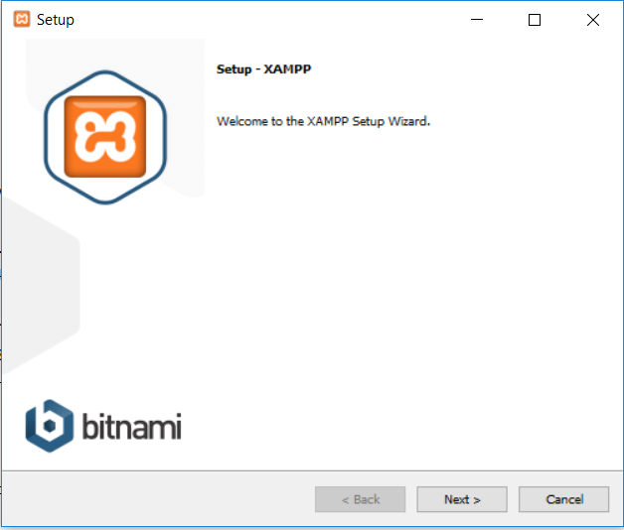

**Next,**

Please select the MySQL and phpMyAdmin components, all other components are optional. Like so,

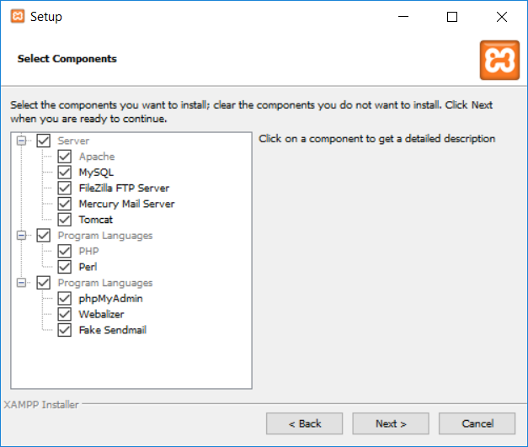

**Next,**

Select the installation location: install Xampp in the C:\xampp location, click next, your installation will begin.

**Step 2 Xampp configuration**

After successfully installing the XAMPP in your local machine open the Xampp control panel by searching **“XAMPP control panel’** in the windows search bar, a pop-up window appears like so;

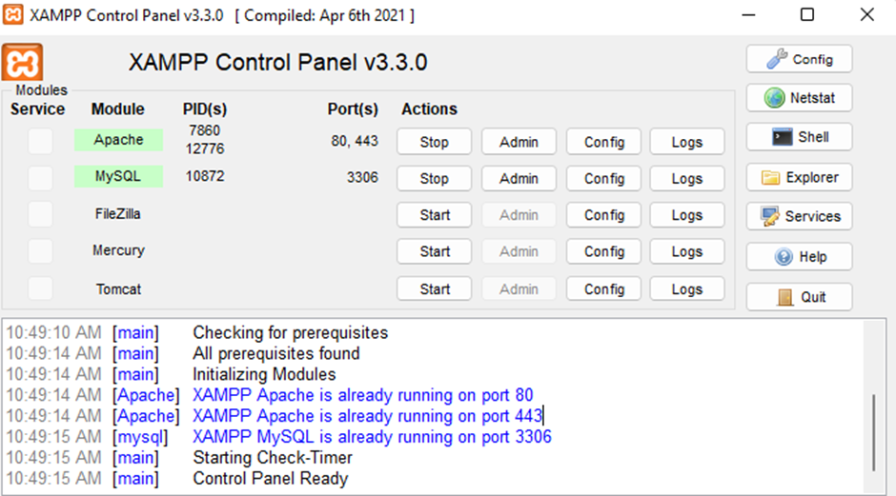

**Next,**

Start the Apache server and MySQL database by clicking the **start**buttons as shown below, the Apache and Sql should turn green then you’ll know you have successfully configured Xampp. You’ll see a port number just in front of the Apache column. You can stop the service whenever you want and start any service by just clicking the start button.

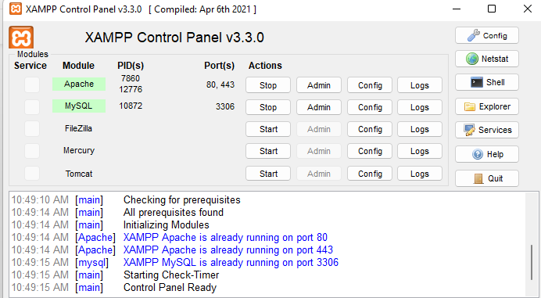

**Step 3 Xampp configuration**

When the project download is complete, unzip the project, copy the unzipped folder and head over to your XAMPP directory which you created in Local Disk C: there you’ll find a folder named “htdocs” for example C:\xampp\htdocs.

Inside the “htdocs” folder, paste the project folder (the extracted one). Then Open your any browser; the recommended browser is Google Chrome or Mozilla Firefox.

Then, go to URL “http://localhost/Farmerspride/Farmerspride/ “.

To access the Database, go to URL http://localhost/phpmyadmin/

Click on the “Import” tab and choose the database file (.sql) which is provided under the folder naming “DATABASE FILE”.

All the login details are provided inside the project folder, check that out and enter in order to use it